**QUESTION 3 : -**

**CODE : -**

#include <GL/glut.h>

#include <math.h>

void Circle(GLfloat x, GLfloat y, GLfloat r){

int i;

int linesdrawn = 100;

GLfloat twicePi = 2.0f * 3.14;

glBegin(GL_LINE_LOOP);

for(i = 0; i <= linesdrawn;i++)

{

glVertex2f(

x + (r * cos(i * twicePi / linesdrawn)),

y + (r* sin(i * twicePi / linesdrawn))

);

}

glEnd();

glFlush();

}

void lineB(float x1 , float y1 , float x2 , float y2)

{

glBegin(GL_LINES);

glVertex2f(x1,y1);

glVertex2f(x2,y2);

glEnd();

}

void displayMe(void)

{

glClear(GL_COLOR_BUFFER_BIT);

glBegin(GL_LINES);

glColor3f(0,1,0);

lineB(-0.5,0,0.5,0.0);

lineB(-0.5,0,-0.4,0.2);

lineB(-0.3,0,-0.4,0.2);

lineB(-0.1,0,0.0,0.2);

lineB(0.1,0,0,0.2);

lineB(0.5,0,0.4,0.2);

lineB(0.3,0,0.4,0.2);

lineB(-0.3,0,-0.3,-0.2);

lineB(-0.1,0,-0.1,-0.2);

lineB(-0.3,-0.2,-0.1,-0.2);

lineB(0.3,0,0.3,-0.2);

lineB(0.1,-0.2,0.3,-0.2);

lineB(0.1,0,0.1,-0.2);

Circle(-0.2,-0.1,0.1);

Circle(0.2,-0.1,0.1);

glFlush();

}

int main(int argc, char** argv)

{

glutInit(&argc, argv);

glutInitDisplayMode(GLUT_RGB);

glutInitWindowSize(500, 500);

glutCreateWindow("ABHISHEK SHARMA");

glutDisplayFunc(displayMe);

glutMainLoop();

return 0;

}

**COMMANDS : -**

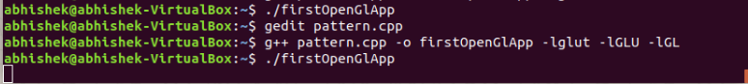

**OUTPUT : -**

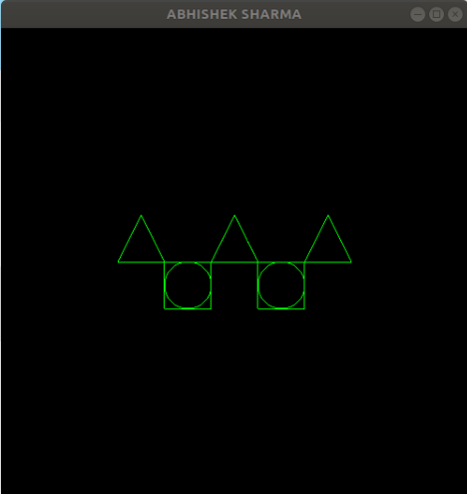

**QUESTION 1: -**

**CODE : -**

#include <GL/glut.h>

#include <math.h>

#include<stdlib.h>

#include<stdio.h>

int a1,a2,a3,b1,b2,b3;

void lineB(float x1 , float y1 , float x2 , float y2){

glBegin(GL_LINES);

glVertex2f(x1,y1);

glVertex2f(x2,y2);

glEnd();

}

void triangle( int x1 , int y1, int x2 , int y2 , int x3 , int y3){

lineB(x1,y1,x2,y2);

lineB(x2,y2,x3,y3);

lineB(x1,y1,x3,y3);

}

void displayMe(void)

{

glClear(GL_COLOR_BUFFER_BIT);

glBegin(GL_LINES);

glColor3f(0,0,1);

glRotatef(45, 0, 0, 1);

triangle(a1,b1,a2,b2,a3,b3);

glFlush();

}

void init(){

glClearColor(0,0,0,1);

glMatrixMode(GL_PROJECTION);

glLoadIdentity();

gluOrtho2D(0,500,0,500);

}

int main(int argc, char** argv)

{

printf("Enter the value of x1 : ");

scanf("%d",&a1);

printf("Enter the value of y1 : ");

scanf("%d",&b1);

printf("Enter the value of x2 : ");

scanf("%d",&a2);

printf("Enter the value of y2 : ");

scanf("%d",&b2);

printf("Enter the value of x3 : ");

scanf("%d",&a3);

printf("Enter the value of y3 : ");

scanf("%d",&b3);

int scale = 10;

a1 = a1;

b1 = b1+scale;

a2 = a2-scale;

b2 = b2-scale;

a3 = a3+scale;

b3 = b3-scale;

glutInit(&argc, argv);

glutInitDisplayMode(GLUT_SINGLE|GLUT_RGB);

glutInitWindowPosition(0,0);

glutInitWindowSize(600,600);

glutCreateWindow("Abhishek");

init();

glutDisplayFunc(displayMe);

glutMainLoop();

return 0;

}